**Stock**

* Stocks, each unit of which is called a share, represent ownership of a company. Stocks, owned either directly or through a mutual fund or ETF, will likely form the majority of most investor's portfolios.

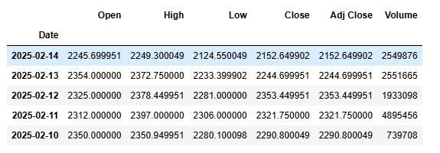

**Key Definitions**

**Open:** The opening price of a stock at the beginning of a trading day.

**High:** The highest price a stock reaches during a trading day.

**Low:** The lowest price a stock reaches during a trading day.

**Close:** The closing price of a stock at the end of a trading day.

**Adj Close:** The adjusted closing price of a stock, which takes into account any dividends, stock splits, or other corporate actions that occurred during the day.

**Volume:** The number of shares of a stock that were traded during a particular trading day. This is an important indicator of market activity and can provide insight into the level of buying and selling interest in a particular stock.

* There are approximately 252 trading days in an year with an average of 21 days per month, or 63 days per quarter. Out of a possible 365 days, 104 days are weekends (Saturday and Sunday) when the stock exchanges are closed.
* In last 90 days, the average closing price for Adani Enterprises was about ₹3517.
* Min price in the last 90 days clocked 1565.
* For about 75% of time the stock was trading below ₹3928 and it clocked maximum of ₹4165. The maximum volume of shares traded on a single day was 43885579 with median quantity being 1822552.
* Based on the above few points, on broad level we can certainly say that the stock is highly volatile

## **Day-to-day percentage change(Daily returns)**

* Daily percentage change in the price of the stock is calculated on the basis of percentage change between 2 consecutive days' closing prices. Let's say if the closing price of the stock yesterday was ₹500 and today the stock closed as ₹550. So, the percentage change is 10%. i.e. ((550–500) / 500)*100.

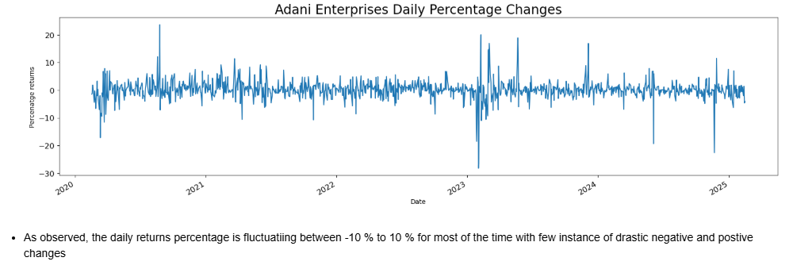

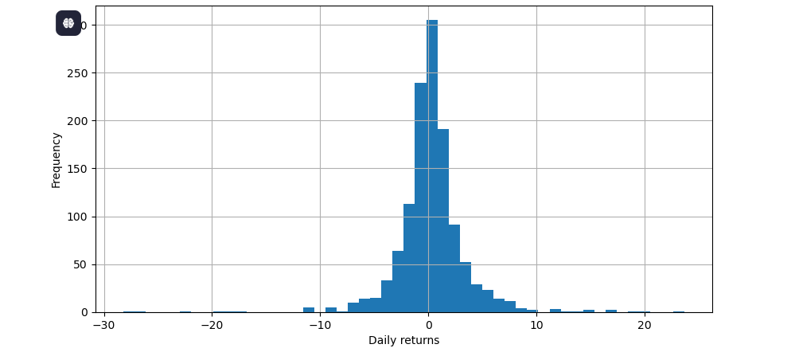

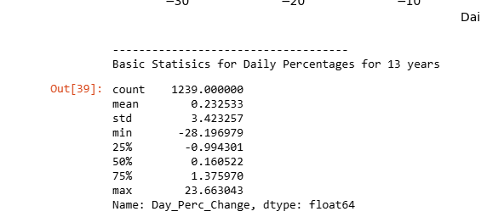

* The daily returns histogram is centered about origin. For the past 13 years, the mean daily returns has been about 0.161993% and for most of the days the daily return was less than 1% implying that the ADANI Enterprises stock has been less volatile over the period. During the period, the highest % change in positive direction was observed to be 27.367529% and was 38.749320% in negative direction

## **Correlation Analysis Of Stocks with Pair plot and Joint plots**

* “Never put all your eggs in a single basket”
* Whenever we go for the diversification of the portfolio, we would NOT want the stocks to be related to each other. Mathematically, Pearson's correlation coefficient (also called Pearson's R value) between any pair of stocks should be close to 0. The idea behind is simple — suppose your portfolio comprises of the stocks that are highly correlated, then if one stock tumbles, the others might fall too and you're at the risk of losing all your investment!
* I selected the aforementioned stocks to perform the correlation analysis. All these stocks are from different segments of Industry and Market cap. You are free to choose the stocks of your interest. the procedure remains the same.

**Volatility analysis**

* Volatility is one of the most important pillars in financial markets. A stock is said to have high volatility if its value can change dramatically within a short span of time. On other hand, lower volatility means that value of stock tends to be relatively steady over a period of time. These movements are due to several factors including demand and supply, sentiment, corporate actions, greed, and fear, etc. Mathematically, volatility is measured using a statistical measure called 'standard deviation', which measures an asset's departure from its average value.
* We have already calculated the intraday returns (daily returns) of the ADANI Enterprises stock and several other stocks. Next, we will calculate the 7-day rolling mean(also called moving average) of the daily returns, then compute the standard deviation (which is square root of the variance) and plot the values.

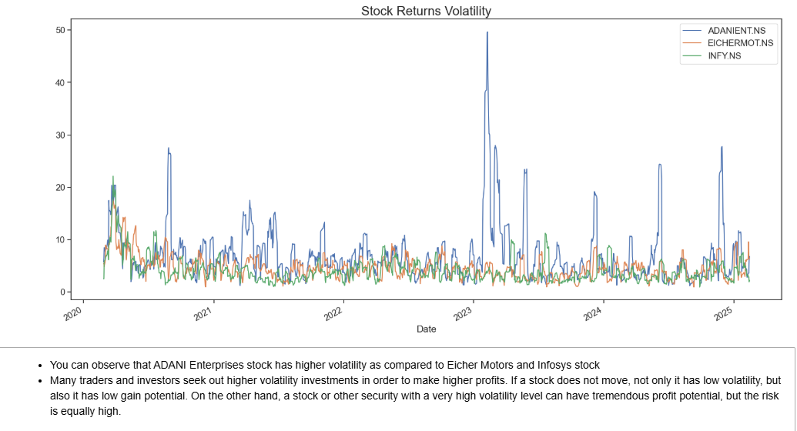

## **Technical Analysis**

**Technical Indicators**

* Investors usually perform due diligence on a handful of companies to select their target companies. There is no guarantee that an investor will make money and some investors lose some, if not all, of their investments hence it is wise not to invest in a company that is going to go bust or that is overvalued and its share price is already too high.
* Investors usually perform fundamental analysis on a company to understand whether it is worth buying its stock. Once they have selected the chosen companies to invest their money in, they then need to evaluate when to buy the stock. Time is important in stock investing too. This is where the technical indicators can come in handy.
* ***An investor performs technical analysis to compute technical indicators. These indicators can help an investor determine when to buy or sell a stock.***
* There are a large number of technical indicators available that are used by the investors. The key is to use a handful of them that meets the trading strategies of the investors and make sense for the current market situation. Too many indicators can clutter the charts and add unnecessary noise.
* The technical indicators use the OHLCV data. it means the open, high, low, close, and volume of trades. These measures of a stock can be used to compute technical indicators.
* The technical indicators can help us with our investment choices.
* There is a large number of technical indicators available. The technical indicators can be grouped into Momentum Indicators, Volume Indicators, Volatility Indicators, Trend Indicators, and Others Indicators.

### ****Crossover Analysis****

A crossover analysis is a technical analysis technique used to identify potential buy and sell signals in a stock's price trend. In the case of ADANIENT.NS, we can use a crossover analysis to identify when the 50-day moving average crosses above or below the 200-day moving average.

The 50-day moving average represents the average price of the stock over the past 50 days, while the 200-day moving average represents the average price of the stock over the past 200 days. By comparing these two moving averages, we can get a sense of the overall trend of the stock price.

When the 50-day moving average is above the 200-day moving average, it is considered a bullish signal, indicating that the stock price may continue to rise. Conversely, when the 50-day moving average is below the 200-day moving average, it is considered a bearish signal, indicating that the stock price may continue to fall.

To perform a crossover analysis, you will need to plot two moving averages for the stock price, typically a shorter-term moving average (e.g. 50-day moving average) and a longer-term moving average (e.g. 200-day moving average). The crossover occurs when the shorter-term moving average crosses above or below the longer-term moving average, indicating a potential trend reversal.

The rolling function is used to calculate the rolling mean (moving average) of the closing price over a specified window size (50 days and 200 days in this example). The fill_between function is used to highlight the regions where the 50-day moving average is above or below the 200-day moving average.

Crossover analysis is just one of many technical analysis tools used to analyze stock prices, and should not be used in isolation to make investment decisions. It's important to also consider fundamental analysis, market trends, and other factors that may affect the stock price.

The crossover points are where the 50-day moving average crosses over or under the 200-day moving average. These points can be used as potential buy or sell signals for the stock, depending on the direction of the crossover.

### ****Simple Moving Average Technical Indicator****[¶](http://localhost:8888/notebooks/Downloads/Stock-Prediction-App-main/Stock-Prediction-App-main/Stock_Market_Technical_%26_Fundamental_Analsysis.ipynb#Simple-Moving-Average-Technical-Indicator)

* The simple moving average (SMA) is a widely used technical analysis tool that helps smooth out price action by calculating the average price of a security over a specific period of time, usually 20, 50, or 200 days.
* In the case of Adani Enterprises Ltd. (ADANIENT.NS), the simple moving average over the ***last 50 days is calculated to be around 1807.78. This means that the average price of ADANIENT.NS over the last 50 days has been around Rs. 1807.78.***
* The simple moving average is used by traders to identify trend direction and potential support and resistance levels. ***When the price is above the SMA, it is considered bullish, and when it is below the SMA, it is considered bearish.*** In this case, since the price is above the 50-day SMA, it can be considered as bullish.
* One important thing to note about ***SMA*** is that it ***gives equal weightage to all the price points in the time period being considered.*** So, the **more recent prices are given the same weightage as the older prices. *** Therefore, it may not be the most effective tool in volatile markets where prices can fluctuate rapidly.**\*
* ***The formula for calculating the SMA is as follows:***
* ***SMA = (Sum of prices over a given period) / (Number of prices in that period)***

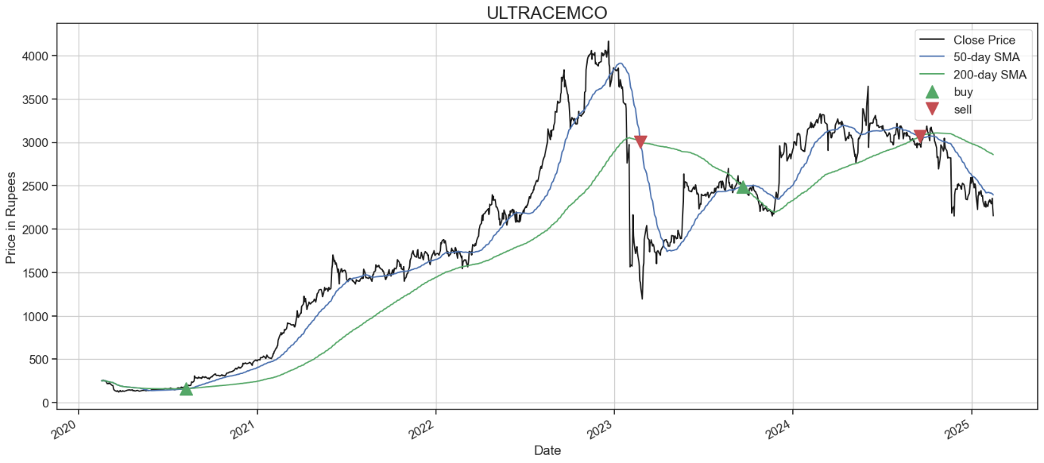

#### **Mathematical Intution**

* The crossover points are where ***the two moving averages intersect***. These points represent potential buy or sell signals for the stock, depending on the direction of the crossover.
* Mathematically, we can calculate the moving averages as follows:

**Simple Moving Average = Sum of stock prices over the period / Number of periods**

* We can then compare the 50-day and 200-day moving averages using the following

**Strategy:**

1. **If 50-day moving average > 200-day moving average, it is a bullish signal**
2. **If 50-day moving average < 200-day moving average, it is a bearish signal.**

The crossover points occur when the two moving averages intersect. At this point, the direction of the crossover will determine whether it is a potential buy or sell signal for the stock.

**Exponential Moving Average Technical Indicator**

* The **exponential moving average (EMA)** is a type of moving average that gives ***greater weight to more recent data in the time series, while also taking into account older data.*** The EMA is calculated using a smoothing factor that places a greater weight on recent data points. ***This can make it more responsive to price changes compared to a simple moving average (SMA).***
* Below, we calculated the 50-day EMA and plotted it along with the closing price of ADANIENT.NS. We also **added buying and selling signals based on the crossover of the EMA with the closing price.** ***When the closing price crosses above the EMA, it is considered a buying signal, and when the closing price crosses below the EMA, it is considered a selling signal***.
* As we can see from the plot, the **EMA generally tracks the closing price quite closely.** ***We can also see that there are several instances where the buying and selling signals are generated***, indicating potential opportunities to enter or exit the market.
* **It's important to note that this is just one of many technical indicators that can be used to analyze stock prices, and it should be used in conjunction with other indicators and fundamental analysis to make informed trading decisions.**

* ***The formula for calculating exponential moving average (EMA) is as follows:***

**EMA = (Close - EMA_prev) * multiplier + EMA_prev**

***Where:***

* Close is the current closing price of the asset
* **EMA_prev** is the previous period's EMA multiplier is a smoothing factor that determines the weight of the current period's price in the calculation.
* **The formula for calculating the multiplier is: 2 / (N + 1), where N is the number of periods in the EMA.**

**After calculating the initial EMA value, we can use the following formula to calculate the EMA for the next period:**

* **EMA[today] = (Price[today] - EMA[yesterday]) * (2 / (1 + N)) + EMA[yesterday]**

**Strategy:**

* If 50-day moving average > 200-day moving average, it is a bullish signal
* If 50-day moving average < 200-day moving average, it is a bearish signal.

**Observations**

* This code will plot a graph with the stock price, EMA, buy signals as green triangles, and sell signals as red triangles. The buy and sell signals are determined by comparing the EMA with the stock price.

***Some insights that we can gather from this graph include:***

* The stock price seems to follow the EMA closely, indicating that the EMA is a good indicator of the stock's trend.
* The buy and sell signals can be used to time the trades, as they indicate when the stock price is expected to rise or fall.
* There are some false signals in the buy and sell signals, which may result in losses if acted upon.
* Therefore, it's important to use these signals in conjunction with other indicators and perform thorough analysis before making any trading decisions.

**MACD Technical Indicator**

* The Moving Average Convergence Divergence (MACD) indicator is one of the most popular technical oscillator indicators.
* It helps us understand the relationship between the moving averages. Convergent is when the lines move closer to each other and divergence is when the lines move away from each other. The lines here are the moving averages.
* MACD is a trend-following momentum indicator. It can help us assess the relationship between two moving averages of prices. Subsequently, the MACD indicator can be used to compute a trading strategy that signals us when to buy or sell a stock.
* Before I begin, it's worth mentioning that a moving average is a rolling average value of a predefined historic period. As an instance, the simple 10-day moving average is computed by calculating the average of the past 10 days period. The exponential moving average, on the other hand, assigns higher importance to the recent values. It can help us capture the movements of a stock price better.
* **Three main steps to calculate MACD:**
* Step 1: Calculate the MACD line:
  + Calculate the 26-day exponentially weighted moving average of the price. This is the long term line.
  + Calculate the 12-day exponentially weighted moving average of the price. This is the short term line.
  + Calculate the difference between the 26-day EMA and 12-day EMA lines. This is the MACD line.
* Step 2: Calculate the Signal line from the MACD line:
  + Calculate the 9 days exponentially weighted moving average of the MACD line. This is known as the signal line.
* Step 3: Compute the histogram: Distance between MACD and the Signal
  + We can then calculate the difference between the MACD and the Signal line and then plot it as a histogram. The histogram can help us find when the cross-over is about to happen.
* ***The histogram is the difference between MACD and the Signal line***
* The histogram's length can be used to understand the trend better. When the histogram bars are not increasing then it can imply that the prices are not volatile and a big move might happen in the opposite direction soon.
* Although the usual approach is to use the parameters as described above but it really depends on the stock, the market, and the investor. We can choose different parameters and optimize the parameters that meet our trading style and the stock we are interested in.

**Strategy:**

* We can use the cross-over between MACD and the Signal line to create a simple trading strategy. This is where the MACD line and the signal line cross over each other.
  + Sell Signal: The cross over: When the MACD line is below the signal line.
  + Buy Signal: The cross over: When the MACD line is above the signal line

**Bullish vs Bearish:**

* Bearish: When the MACD and Signal lines are below 0 then the market is bearish.
* Bullish: When the MACD and Signal lines are above 0 then the market is bullish.

**Key Points**

* MACD is based on moving averages which imply that the past can impact the future. This is not always true. Additionally, there is a lag present due to the moving averages hence the generated signals are after the move has started.
* The standard setting for MACD is the difference between the 12- and 26-period EMAs. We could use MACD(5,35,5) for more sensitive stocks and MACD(12,26,9) might be better suited for weekly charts. It all depends on the investor.
* One keynote to remember is to always analyze the short and long-term price trend along with other factors. And rememeber sometimes a stock that might appear overbought might still move upwards due to other market factors.

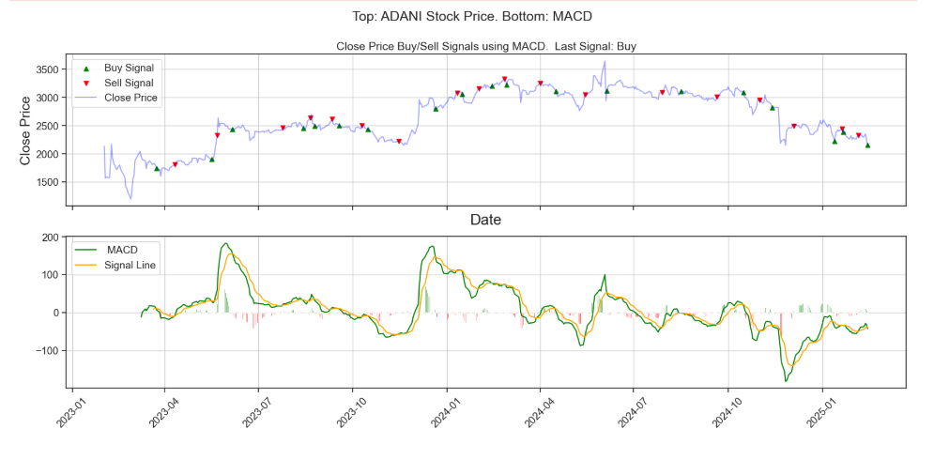

**RSI Technical Indicator**

* RSI stands for Relative Strength Index. It's a widely used technical indicator and this is mainly due to its simplicity. It relies on the market and we can use the indicator to determine when to buy or sell a stock.
* RSI requires us to compute the recent gains and losses. The recent specified time period is subjective in nature. We use the RSI indicator to measure the speed and change of price movements.
* RSI is an oscillating indicator. It can help us understand the momentum better. Note, momentum is the change of price and size. Therefore, the RSI indicator can help us understand when the stock price will change its trend.
* The key to using this indicator is to understand whether a stock is overbought or oversold.

**Calculation:**

* The calculation is extremely simple.
  + Firstly, we have to determine the time period. Usually, a 14 day time period is chosen but it could depend on the investor's own view of the market and the stock.
  + Secondly, we have to compute the relative strength which is known as RS. RS is the average gain over the average loss. To explain it further, RS is the average gain when the price was moving up over the average loss when the price change was negative.
  + Calculate RSI as 100 — (100/(1+RS))
  + The RSI value is between 0–100

**Strategy:**

* **Overbought:** When the RSI is above 70%. Essentially, overbought is when the price of a stock has increased quickly over a small period of time, implying that it is overbought.
* The price of an overbought stock usually decreases in price.
* **Oversold:** When the RSI is below 30%. Essentially, oversold is when the price of a stock has decreased quickly over a small period of time, implying that it is oversold. The price of an oversold stock usually increases in price.
* There are way too many strategies that are dependent on the RSI indicator.
* A simple strategy is to use the RSI such that:
* **Sell:** When RSI increases above 70%
* **Buy:** When RSI decreases below 30%.
* We might decide to use different parameters. The point is that we can optimize the parameters that meet our trading style, the market and the stock we are interested in.

**Key Points**

* The signals are not always accurate. The RSI signals are dependent on the price of the stock only and this is not the only factor that can change the price of a stock. Plus it's highly subjective.
* As an instance, a company can launch a product when a stock is oversold and that could further increase the price of the stock.
* Therefore, always consider the market factors and also use the short and long term price trend when buying or selling a stock.

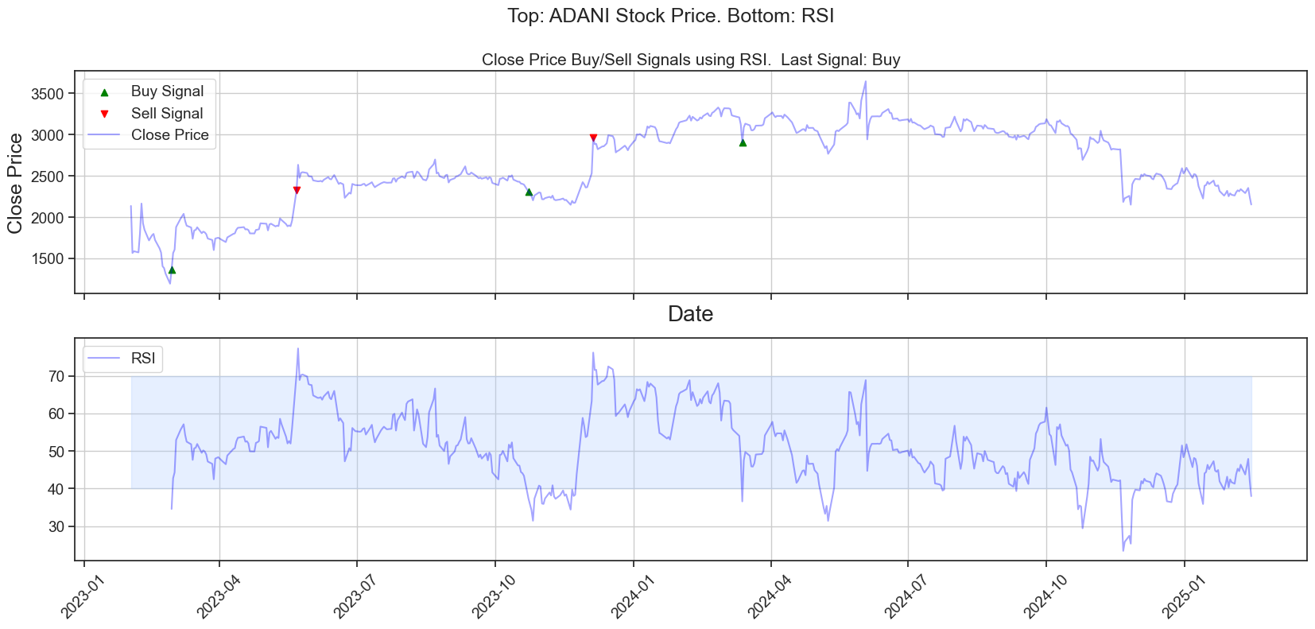

**Bollinger Bands Technical Indicator**

* It is one of the most popular technical indicators. And this is mainly due to its simplicity.
* There are two main components of a Bollinder band indicator:
  1. Volatility Bolinger Bands
  2. Moving averages
* **Essentially, the steps are:**
  + Middle band: Calculate the moving average of the price, usually 20 days moving average.
  + Upper band: Calculate two standard deviations above the moving average.
  + Lower band: Calculate two standard deviations below the moving average.
* The more volatile the stock prices, the wider the bands from the moving average. It's important to look at the shape/trend of the bands along with the gap between them to understand the trend and stock better.
* The standard deviations capture the volatile movements and hence we compute standard deviations above and below the upper and lower bands to capture the outliers. Consequently, 95% of the price movements will fall between the two standard deviations
* **Strategy:**
* A simple trading strategy could be to:
  + Sell: As soon as the market price touches the upper Bollinger band
  + Buy: As soon as the market price touches the lower Bollinger band
* This is based on the assumption that the stock must fall back (from the uptrend) and eventually touch the bottom band.
* At times, the Bollinger Band Indicator signals us to buy a stock but an external market event such as negative news can change the price of the stock. Therefore it's important to use the indicator as just an indicator that can sometimes be wrong.

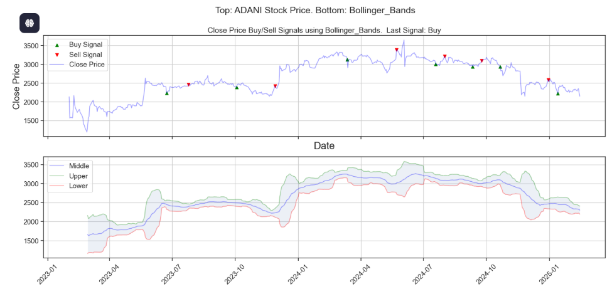

* The library has a bonus function. We can add all of the available technical indicators that have been coded in the ta library by calling the add_all_ta_features function.
* For this code to work, create a dataframe and ensure it contains the Open, High, Low and Close columns.
* The library has a bonus function. We can add all of the available technical indicators that have been coded in the ta library by calling the add_all_ta_features function.
* For this code to work, create a dataframe and ensure it contains the Open, High, Low and Close columns.

## **Fundamental Analysis**

* There are thousands of publicly listed companies. We can choose to invest our money in all of them but some of the companies are better for our investment than the others.
* There are a large number of methodologies available to analyze and measure the health of a company.
* One of the key methodologies is known as fundamental analysis.
* Fundamental analysis is when an analyst values a stock of a company by assessing the company-level factors such as the state of its balance sheet, market capitalization, how the management of the company is, and so on.
* The fundamental analysis helps us understand what to look for in a company. The result of fundamental analysis is a set of fundamental indicators.
* Therefore, the fundamental analysis uses both the intrinsic value of the stock along with the external factors to compute its value.
* The more we understand about the company we want to invest in, the higher the chances of us deriving the true value of the company.

**Quick Note Worth Mentioning**

* If we know that a company is healthy, it is investing its income to grow itself and is launching new products, its net income is more than its costs and its management is effective, it does not have any debt and the share price is undervalued then we can feel confident that the value of the company is likely to grow and the company won't go bankrupt anytime soon.
* No one can accurately predict the stock market. The market can be volatile and it can change due to an unlimited number of factors.
* I have presented my opinions in this article. This article does not guarantee any positive returns and should be used for educational purposes only. The opinions expressed in the article may change without notice as new information is obtained.
* An investor can lose some, if not all, of his/her investments therefore it is important to seek a professional's advice before investing money in a company.
* The stock market cannot always be timed and there is no guarantee that an investor will earn a profit.
* The key concept to understand is that each company has its intrinsic value. The fundamental analysis is all about calculating the intrinsic value of the company. This analysis is subjective in nature. There are way too many indicators available and a mix of them can help us value a company.

**Basic Understanding**

* The fundamental analysis should help us understand the following key questions:
  1. What is the market capitalization of a company? Is the company growing and earning profits?
  2. Is my target company under debt? What is their debt-to-equity ratio?
  3. Is the company undervalued or overvalued in terms of its market and book value, sales, earnings, and profits?
  4. What is their price per earnings and price per earnings growth ratios?
  5. What are the returns on assets and equities? What is the dividend payout ratio?
* There are a large number of useful fundamental indicators such as dividend yield, EPS, and so on

### ****Valuation measures****

#### **Market Capitalization:**

* Let's start by understanding what market capitalization is. Market capitalization is also known as market cap. The market cap is one of the measures to determine the size of a company. We can use the market cap measure to categorize a company into a large, medium, or small-sized company category.
* The market capital figure informs us about the market value of a company which is simply the product of outstanding shares and the current price of one share. Therefore, we can use the market cap figure to estimate how valuable the company is to the market.
* Usually, large-cap companies have a market cap greater than 10𝐵𝑖𝑙𝑙𝑖𝑜𝑛,𝑡ℎ𝑒𝑚𝑒𝑑𝑖𝑢𝑚𝑖𝑠𝑎𝑛𝑦𝑤ℎ𝑒𝑟𝑒𝑓𝑟𝑜𝑚10Billion,themediumisanywherefrom2B to 10𝐵𝑎𝑛𝑑𝑡ℎ𝑒𝑠𝑚𝑎𝑙𝑙−𝑐𝑎𝑝𝑖𝑠𝑎𝑛𝑦𝑤ℎ𝑒𝑟𝑒𝑏𝑒𝑙𝑜𝑤10Bandthesmall−capisanywherebelow2B. We can further break the cap down into more categories if needed. Generally, it's wise to diversify the portfolio and add a mix of large, medium, and small-cap companies' stocks in the portfolio.
* Author's Opinion: The smaller cap stocks are generally riskier and are more volatile than the large market cap companies. The large-cap companies yield fewer returns than the small-cap companies but they are generally safer investments.

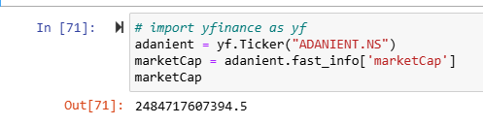

#### **PS Ratio**

* The P/S ratio, which is also known as the Price To Sales Ratio, is used to inform about how much the market capitalization exceeds the sales of a company. Typically, past 12 months sales are used.
* It is essentially the ratio of market capitalization to the sales of a company. Therefore, the ratio can help us understand how much the other investors are paying for one dollar of sales of stock.
* The ratio is computed by dividing the market capitalization of the share by the total sales of a company. Therefore, as the number of outstanding shares or the share price of a company increases, the ratio increases. If the sales of a company decrease then the ratio increases.
* Author's Opinion: The key point to take is that if the ratio is lower than 1 then the company is undervalued and if the ratio is greater than 1 then the company is overvalued. Generally, the higher the value, the more the stock is valued by the investors.

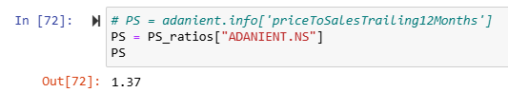

#### **PE Ratio**

* The Price to Earnings ratio is one of the most used ratios within the fundamental analysis measures. It can help us determine whether the company is over or undervalued with respect to other companies within the industry.
* There are multiple ways to calculate the ratio. We can either take the market capitalization and divide it by the earnings or we can take the current share price and divide by the Earnings Per Share (EPS). The earnings per share inform us how much the company makes per share. It is merely the total earnings of a company divided by the outstanding shares. If the EPS is positive then the company is profitable. Therefore it makes more than it costs.
* PE ratio is the Trailing Price To Earning ratio. The word trailing here refers to the earnings of the last 12 months. Essentially, we take the market capitalization and divide it by the actual last 12 month's earnings per share. We can use the PE ratios to compare similar companies within an industry and to determine whether the company stock price is over or undervalued.
* A company with a higher PE ratio usually has a higher earnings growth rate.
* Author's Opinion: The key point to take is that PE needs to be compared with the companies within the same industry. The higher the value, the more the company is valued.

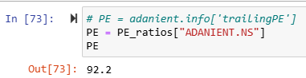

**PEG ratio**

* The PEG ratio is also known as the Price To Earnings Ratio Over Earnings Growth Rate. This is computed by calculating the PE ratio and dividing by the earnings growth. We can use the annual earnings growth rate.
* We can use the PEG ratio to compute the true value of a stock. The lower the PEG ratio, the undervalue the stock is. The PEG ratio can help us understand how fast a company can grow.
* The higher the PEG ratio, the more the company is valued, therefore the lower the value, the undervalue the company is. When both the PE and PEG ratios are high then they are good indicators that the company is overvalued.

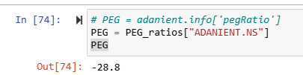

#### **PB Ratio = Price/Book Ratio**

* The price to book ratio is computed by taking the market capitalization and dividing it by the book value of the company. We can also compute it by taking the current share price and dividing it by the book value per share.
* The book value is the difference between the assets and liabilities. Imagine if all of the assets of a company are liquidated to pay all of the liabilities then whatever we are left with is known as book value. The market value on the other hand is the price that the market values the company as.
* Author's Opinion: The key point to take is that if the ratio is lower than 1 then the company is undervalued and if the ratio is higher than 1 then it is overvalued. The higher the value, the more the company is valued. We should ensure that the book value and market value of a company are positive. Generally, the lower the ratio, the better the investment

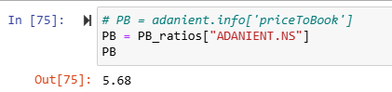

### ****Management Effectiveness****

#### **ROA**

* Each company has its assets, liabilities, and annual net income that it generates from the assets. The ROA stands for Return On Assets. The ROA measure informs us about the income the company can generate from its assets.
  + 𝑅𝑂𝐴=𝑁𝑒𝑡𝐼𝑛𝑐𝑜𝑚𝑒𝐴𝑣𝑒𝑟𝑎𝑔𝑒𝐴𝑠𝑠𝑒𝑡𝑠ROA=NetIncomeAverageAssets
* Therefore if a company has effective management then it will be reflected in the ROA.
* Author's Opinion: The higher the ROA value, the more effective the management of a company because the more the company can possibly generate more net income from its assets.

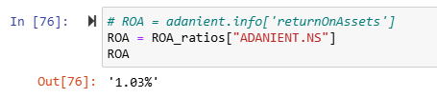

#### **ROE**

* The ROE stands for Return On Equity.
* Remember that shareholder equity, or commonly known as equity, is the difference between the assets and the liabilities of a company.
* 𝑅𝑂𝐴=𝑁𝑒𝑡𝐼𝑛𝑐𝑜𝑚𝑒𝑠ℎ𝑎𝑟𝑒ℎ𝑜𝑙𝑑𝑒𝑟𝑒𝑞𝑢𝑖𝑡𝑦ROA=NetIncomeshareholderequity
* This is again an indicator of how efficient the management of a company is. It informs us about the returns of a company in relation to the equity held by its stockholders.
* Author's Opinion: The higher the value, the better the company in generating returns.

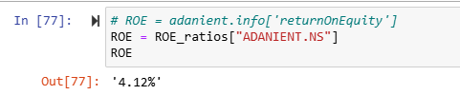

### ****Income Statement****

#### **Profit Margin**

* Profit margin is an important measure as it helps us understand the degree to which the company is generating income over its revenue. It is the ratio of the net income of a company over its revenue.
* Therefore, if a company generates less income than its revenue then it will have a lower profit margin. It is a measure of a company's efficiency. These figures are available in the income statement of a company.
* Author's Opinion: A company that generates a higher profit margin generates higher income when compared to its expenses and therefore is considered a healthier company.

**Operating Margin**

* The operating margin is another measure of profit.
* It is calculated by dividing the operating profit by the sales revenue. The profit is computed by calculating the difference between the revenue and all of the costs of a company.
* These figures are available in the income statement of a company. Author's Opinion: We might be able to conclude that the higher the operating margin, the profitable the company with lower costs.

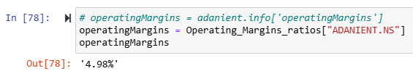

### ****Balance Sheet & Dividends****

#### **Current Ratio**

* The current ratio is one of the important balance sheet ratios to consider
* It is a liquidity ratio and can inform us about the health of a company. It indicates whether the company can pay off its short-term debt.
* It is calculated by dividing the current assets over the current liabilities.
* The key to remember is that the higher the current ratio, the better the company can be considered for investment.
* It is a good indication to invest in a company that has higher assets than its liabilities.
* Author's Opinion: Ideally, the current ratio should be greater than 1 indicating that it can pay-off its liabilities without borrowing the money.

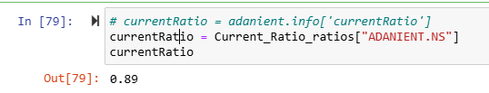

#### **Cash Per Share**

* This is the available cash over the number of outstanding shares.
* Author's Opinion: The more cash there is in a company, the more the business can spend on itself and make positive changes for the shareholders by growing the company or its products as an instance.

#### **D/S Ratio = Total Debt/Equity Ratio**

* This measure is calculated by taking the ratio of liabilities of a company by the equity of the company.
* Remember the equity of a company is the difference between its assets and liabilities. Therefore, a positive number is considered healthier.
* Author's Opinion: Companies that have a higher debt ratio can potentially default on their debt therefore it's wise to choose a company with lower debt to equity ratio and ensuring that it is a positive number.

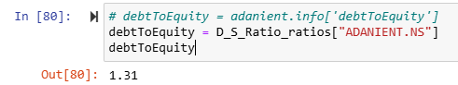

#### **Payout Ratio**

* The payout ratio is directly related to the dividends that the company pays to its shareholders. Some of the most established companies pay a percentage of their earnings to their shareholders.
* The payout ratio is calculated by dividing the dividend amount per share by the earnings per share.
* Some companies do not pay dividends whereas some companies invest a large portion of their income back into their business. When the payout ratio is low then it could mean that the company is investing back into its business. This again could imply, that the company is expanding.
* Author's Opinion: When the payout ratio is high (higher than 100) then it means the company is paying more in dividends than its earnings.

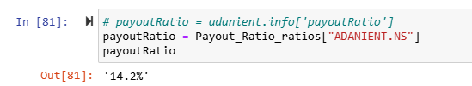

**Resource**

* <https://towardsdatascience.com/data-analysis-visualization-in-finance-technical-analysis-of-stocks-using-python-269d535598e4>
* <https://towardsdatascience.com/making-a-trade-call-using-simple-moving-average-sma-crossover-strategy-python-implementation-29963326da7a>
* <https://medium.com/fintechexplained/automating-stock-investing-technical-analysis-with-python-81c669e360b2>
* <https://medium.com/fintechexplained/speaking-traders-language-14a22df720a6>
* <https://medium.com/fintechexplained/automating-stock-investing-fundamental-analysis-with-python-f854781ee0b4>
* <https://www.investopedia.com/terms/t/todayslow.asp>
* <https://technical-analysis-library-in-python.readthedocs.io/en/latest/>

**Yahoo finance github link and syntax:**